Linux Fundament Assignment 1

Identify System Resources

Find CPU Information: *Command: lscpu*

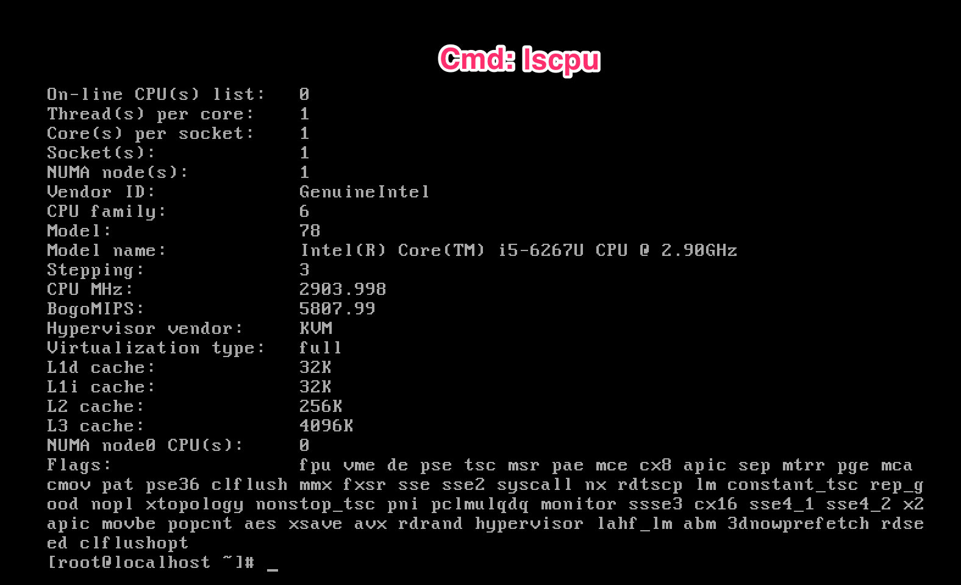

Get Memory Information

*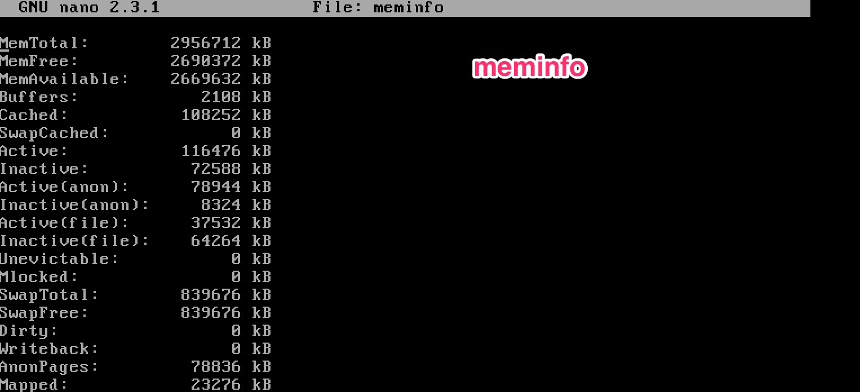Command: nano meminfo*

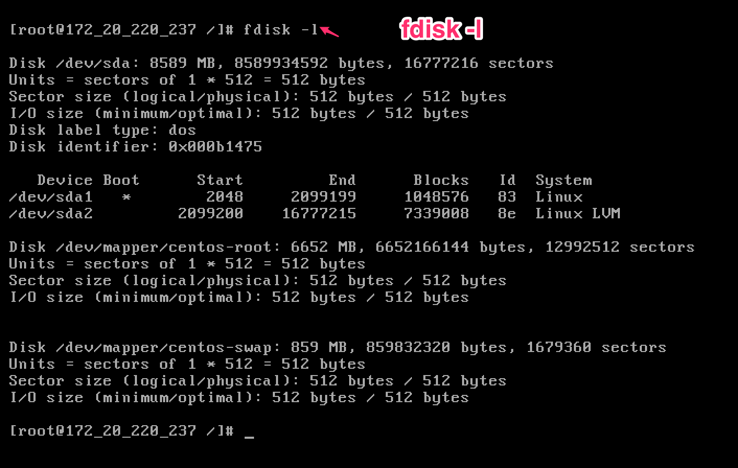Hard drive Information: *Command: fdisk -l*

**Network Overview – ifconfig and resolve.conf**

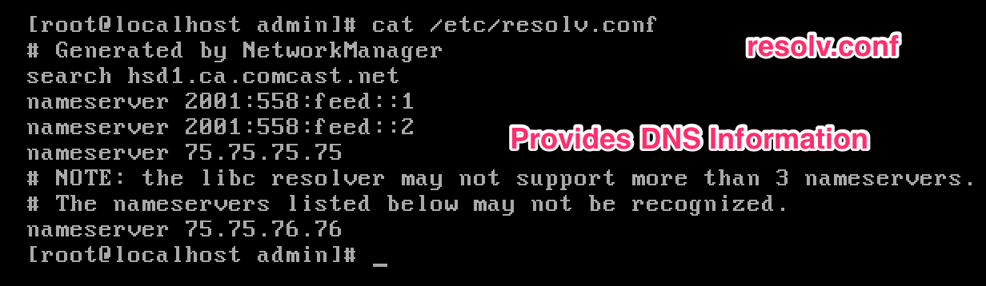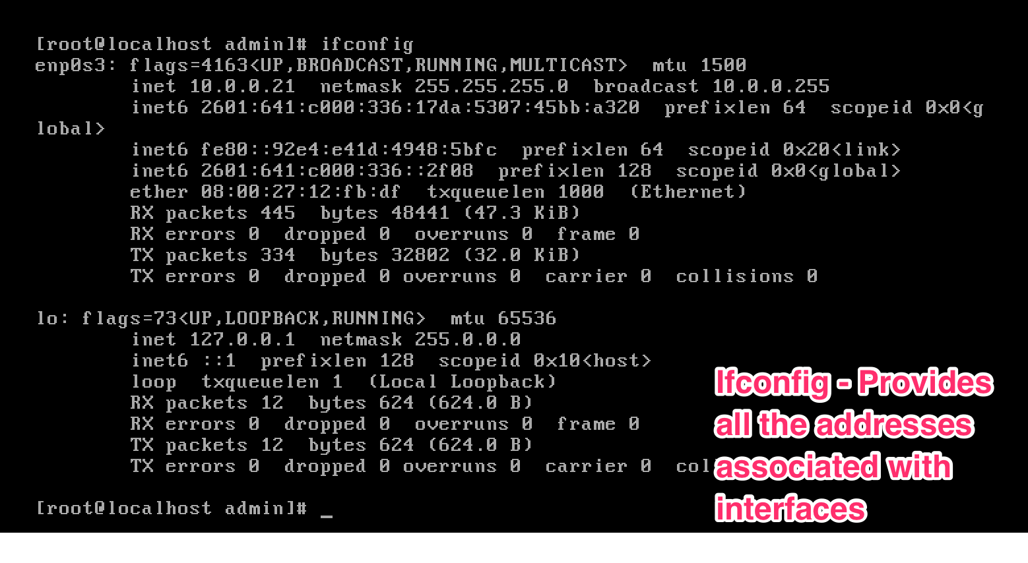

**Question #3**

***Partition Overview – Command: sfdisk -l***

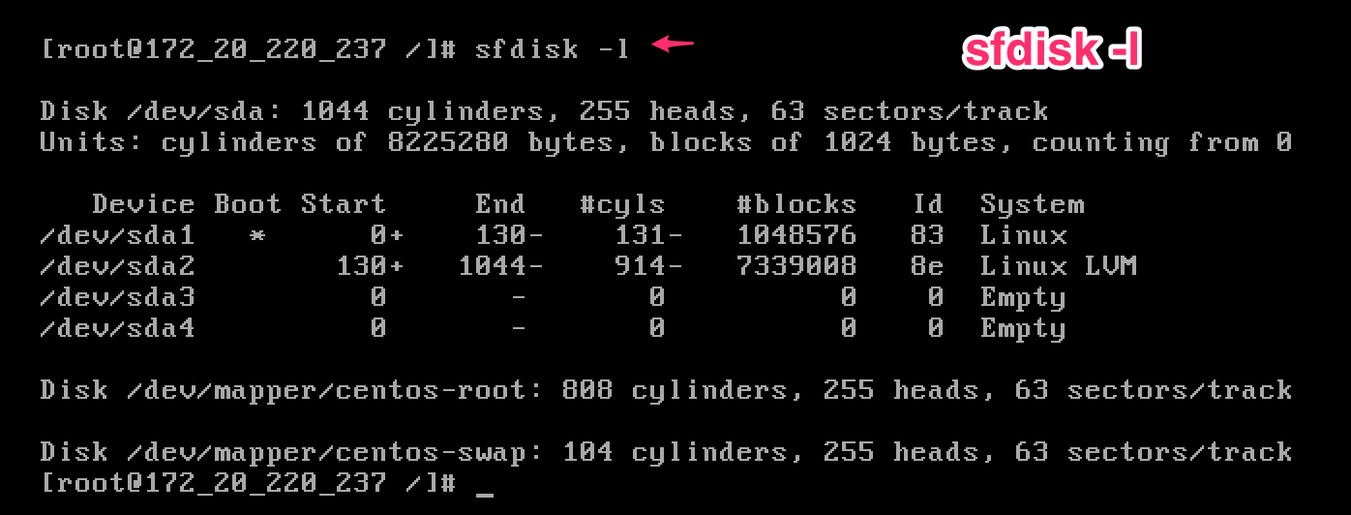

***File System Overview: Command: lsblk***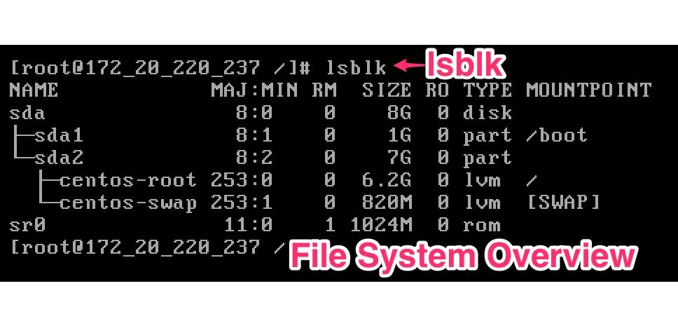

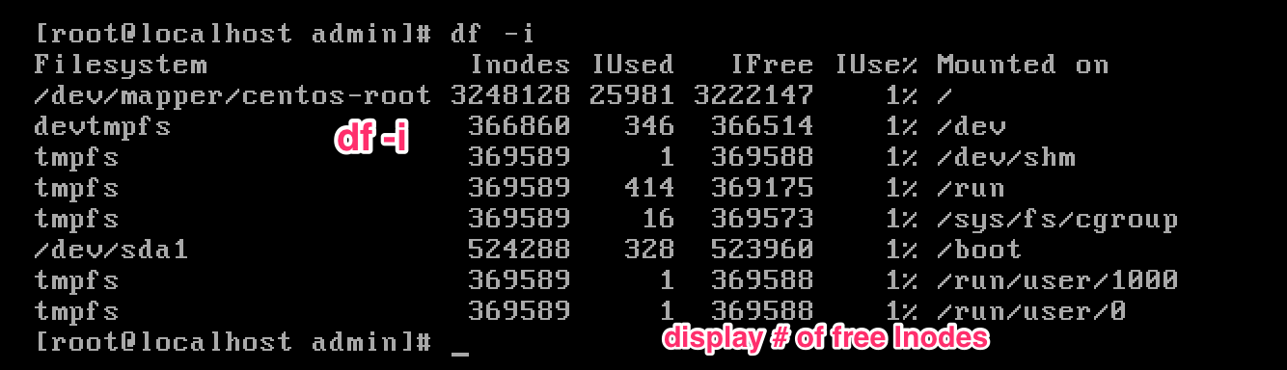**# Of Free iNodes: Command: df –i**

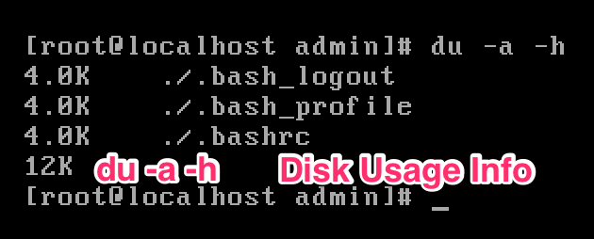**Find Disk Usage: command du –a –h**

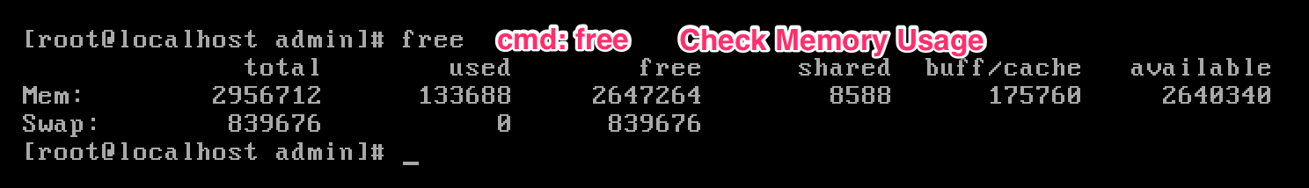**Find Memory Usage: Command: free**

**Gateway Information: Command route -n**

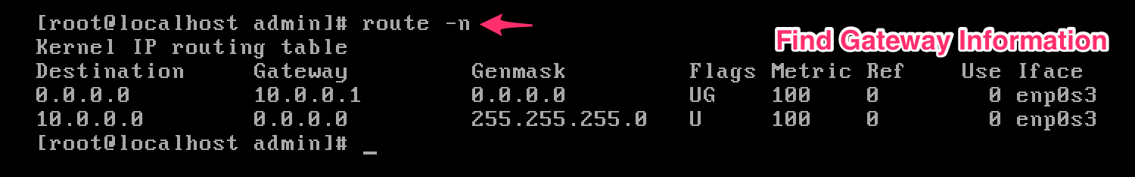

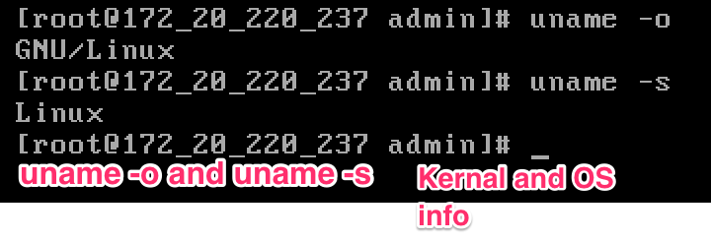**Kernel and OS version**

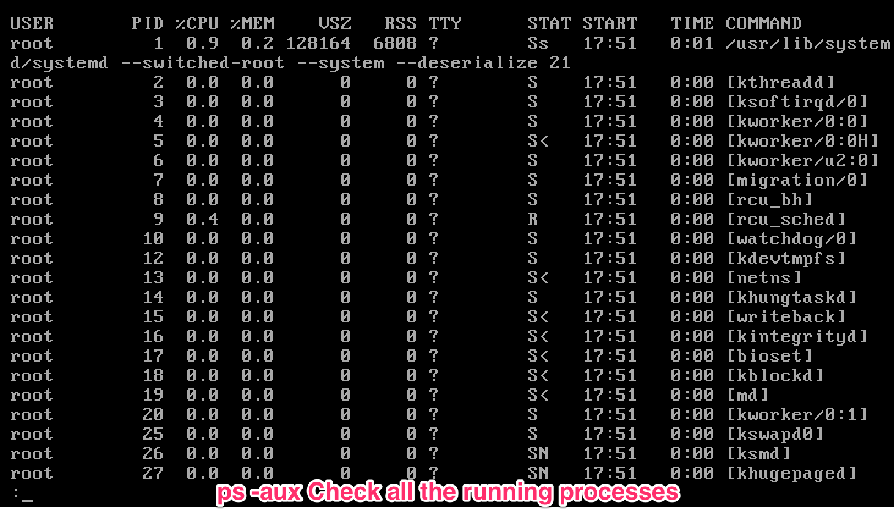**Find The Running Processes**